**Photographs for CMN 150 Task 1 – Analysis Essay: Choose ONE for analysis.**

1. The gris-gris wrestlers of Senegal

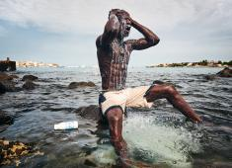

http://www.worldpressphoto.org/collection/photo/2016/sports/christian-bobst

2. A life in death

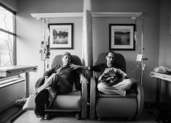

http://www.worldpressphoto.org/collection/photo/2016/long-term-projects/nancy-borowick

3. Reporting Europe’s Refugee Crisis

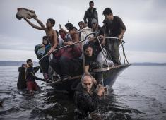

http://www.worldpressphoto.org/collection/photo/2016/general-news/sergey-ponomarev